Essay Outline: Bubble/Web Cluster
There are many ways to pre-write for an essay. For this essay, I would like you to use the Bubble/Web Cluster style. In this style of prewriting, you will create a map like the one below. Each bubble is explained in the list that follows:
- The subject of your writing goes in the center, #1 Bubble. This is known as your Working Thesis.
- You will have three #2 Bubbles branching off from #1. Each of these bubbles should contain an idea that supports your Working Thesis in #1.
- You will have two #3 Bubbles branching off from each #2. That’s a total of six! These bubbles should have examples that support their connecting #2 bubble.
Here is an example of the Bubble/Web in action:
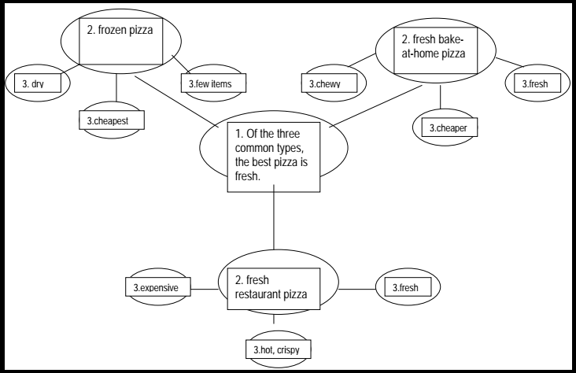

In your Notebook, you need to create a Bubble/Web Cluster, using the following Thesis:
- Conflicts that arise in Th1rteen R3asons Why show that the smallest actions having unintended consequences.
  - That means THIS ↑is what will be in your #1 Bubble.
Your #2 Bubbles should have examples of moments in 13RW that support what is being claimed in the Thesis.
Your #3 Bubbles should have Concrete Details (quotes and/or paraphrasing) that support your #2 Bubbles, which, in turn, should continue to support your Thesis.

