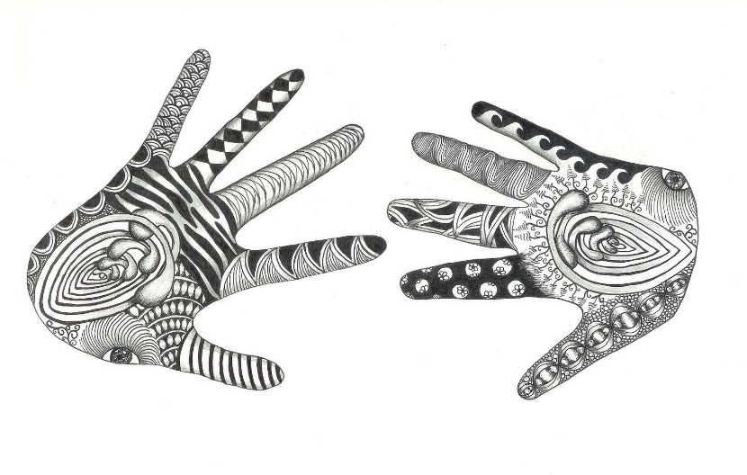

Passion Poster Project

You will be creating a poster or display that showcases your passions and desires, and that will be presented to the class.

So what do you need to do?

First, you will need to trace your hand, your foot, and your head (or you can draw a representation if they are too hard to trace!).
Next, you will need to fill each trace with important information about yourself. Use the following questions as inspiration for each part of the poster/display, but do not feel confined to only these questions:
Hand: What have you made? What do you wish to make? Is there anything you’re passionate about that involves work with your hands?
Foot: Where have you traveled? Where would you like to go? Do you use your feet when exploring your passions?
Head: What is something you know a lot about? What is something you want to learn about? Who or what do you think of that inspires you?

Your poster/display must meet the following criteria:
- It must be multi-genre, meaning that it has to incorporate both text AND imagery (push the boundaries of multi-genre and try using different materials in your creation as well).
- It must effectively convey what you are passionate about, so choose your words and your images wisely.
- It must have your name clearly displayed, and be thoughtfully integrated.

Due Date: __________________

