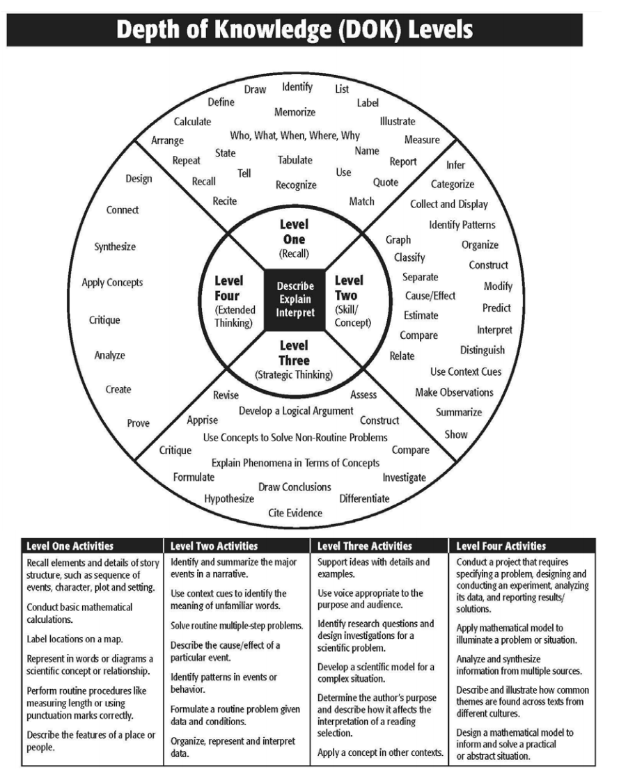

DOK Question Stems
DOK 1  - Can you recall______?  - When did ____ happen?  - Who was ____?  - How can you recognize____?  - What is____?  - How can you find the meaning of____?  - Can you recall____?  - Can you select____?  - How would you write___?  - What might you include on a list about___?  - Who discovered___?  - What is the formula for___?  - Can you identify___?  - How would you describe___? | DOK 2  - Can you explain how ____ affected ____?  - How would you apply what you learned to develop ____?  - How would you compare ____? Contrast_____?  - How would you classify____?  - How are____alike? Different?  - How would you classify the type of____?  - What can you say about____?  - How would you summarize____?  - How would you summarize___?  - What steps are needed to edit___?  - When would you use an outline to ___?  - How would you estimate___?  - How could you organize___?  - What would you use to classify___?  - What do you notice about___?
DOK 3  - How is ____ related to ____?  - What conclusions can you draw _____?  - How would you adapt____to create a different____?  - How would you test____?  - Can you predict the outcome if____?  - What is the best answer to ___? Why?  - What conclusion can be drawn from these three texts?  - What is your interpretation of this text? Support your rationale.  - How would you describe the sequence of____?  - What facts would you select to support____?  - Can you elaborate on the reason____?  - What would happen if___?  - Can you formulate a theory for___? | DOK 4  - Investigate and draw conclusions about how _____ impacts the world today.  - How would you adapt _____ to create ____ that would be applicable in the real world?  - Design _____ to improve _____  - What information can you gather to support your idea about___?  - If you researched _____ and ____ from different time periods, would you find _____?  - Justify why you agree with ______.  - ______’s perspective of _______ is similar/different to _______’s perspective of ________ because _________.  - The theme of ______ is present in the text ______ and ______ which shows that both authors value ________.

From Depth of Knowledge – Descriptors, Examples and Question Stems for Increasing Depth of Knowledge in the Classroom Developed by Dr. Norman Webb and Flip Chart developed by Myra Collins

